

GAME OF GOLF 1093


SCORECARDS: 6 - COMPETITIVE GOLF:
4-BALL BETTER BALL
David Weston, the former secretary of Enmore Park GC, writes the last, in a series of six, the correct way to mark a scorecard - Competitive golf: 4-Ball Better Ball.
Secretary At Work: February 2012 (revised March 2016)

For the benefit of the PLAYER and those members of the Competitions Committee or Professional Staff who have to check that Cards in all types of competitions, it is important that they have been correctly marked and submitted. This sequence of illustrations has been devised to try to ensure that all Competitive Cards fulfil the requirements of the Rules of Golf.

In those Competitions where a computer is in use, the computer will total the Medal score, calculate the Stableford score or work out the Bogey/Par result.

The two most common errors are:
- Something other than, or in addition to, the GROSS SCORE is included in the box for the Player, or the gross score is absent.
- The Markers Gross score is not in the column provided, but is elsewhere on the Card.

The following 6 examples are given. For each there is an explanation sheet and an example of a card.
- Individual Medal (library doc: 1066)
- Individual Stableford (Ladies & Gents for differing Stroke indices) (library doc: 1071)
- Individual Par/Bogey (library doc: 1078)
- Bowmaker (3-Ball Team) (library doc: 1084)
- Pro-Am 4-Ball Team (library doc: 1088)
- 4 Ball Better Ball Pairs.

Note There is no copyright on these illustrations. They may be copied, displayed or transmitted in written or electronic form.

[This document is prepared for guidance and is accurate at the date of publication only. The GCMA will not accept any liability (in negligence or otherwise) arising from any member or third party acting, or refraining from acting, on the information contained in this document.]
This is pairs competition, with the better net score of the pair to count on each hole.

In this type of competition, each player is playing for points on each hole:

3 under par 5
2 under par 4
1 under par 3
Par 2
1 over par 1

The obligations of the committee (Rule 33) and the player (Rule 6) are exactly the same as they are for Medal golf. It is strictly the responsibility of the committee to work out the Stableford points. Both the marker and player should check the net points total for each hole and the round.

Incorrectly marked cards which are received regularly contain both the gross and net scores in the player columns A and B, or the gross score and the points.

4
3

The above is incorrect and may be taken as a score of 43 for the hole. No points would be given for a hole marked in this way.

Columns A and B should contain only the gross score for the hole as in Medal play.

Prior to starting the player should put a mark or cross at the side of each hole at which he/she is entitled to a stroke and 2 marks or crosses at each hole where there is an entitlement of 2 shots. Some players prefer to circle or double circle the square. This enables the marker to calculate the points for the hole and record it in the column provided.

If you cannot score a point on a hole, please pick up.

At the completion of the round, the points score for each 9 holes should be calculated and written in the boxes provided. Addition of the points for each 9 holes will give the total over 18 holes for the team. This should be written in the box provided and then the card signed by the marker and one of the players as being correct.

Some markers will use columns C and D for their pairings score, others will split column D to keep a separation between the two pairs. Either is correct.

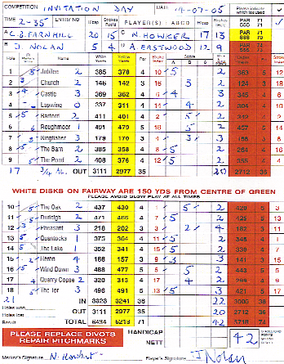The following is an example of how to correctly mark a card.

David Weston is the former secretary of Enmore Park GC

