Contacting us…


If you have any questions about salaries, career path or conditions of employment, please contact us using one of the following methods;

Post
Administration, Committee for Golf Club Salaries, PO Box 59, Alne, York YO61 1ZW

Telephone
01347 830155

Facsimile
01347 833801

Email
golfclubsalaries@hotmail.com
2018

Recommendations

The Committee for Golf Club Salaries

Chairman: Eddie Bullock
(GCMA Member & Director and Golf Consultant )
George Barr (BIGGA Member)
Cameron Dawson (GCMA Member) John Edgington (GCMA Member) Jackie Howe (Chief Executive NGCAA) Niki Hunter (Education Coord’ GCMA)
Tracey Maddison (BIGGA Secretariat)
Scott Reeves (BIGGA Member)

The Principles of Golf Club Management 
A week residential course designed to provide the building blocks for the numerous areas of control that a Golf Club Manager requires. This course is designed for newcomers to the profession of golf club management, or an existing Manager, Secretary or Assistant who wants to bring themselves up-to-date with current management practices. The course content is relevant for both private members clubs or propriety clubs.
Run by the Golf Club Managers’ Association (GCMA), this course has been running in excess of 30 years and is a recognised standard within golf clubs as the primary course for new managers, assistants seeking career progression or those seeking a management role within the industry.

Summary of Course Content
Basic Agronomy & the Golf Course Accounting
The Role of the National and County Unions Health & Safety
Employment Law Golf Club Law
Social Media Marketing
Food & Beverage Operations Membership Schemes
Rules of Golf Running Golf Competitions
Working Secretary study
The fully inclusive price of the course is £995 (VAT exempt).

2018 Locations & Dates
21st – 23rd January Harrogate : Majestic Hotel : BTME 3 day condensed course
12th – 16th March Newbury : Donnington Grove Hotel & Country Club
10th – 14th September Henley Golf Club – Sollihull, Birmingham
19th – 23rd November Wyboston Lakes – North Bedfordshire

Contact Details:
Education Coordinator : Niki Hunter – niki@gcma.org.uk phone contact : 07990 520173

Introduction The Committee for Golf Club Salaries

Following a periodic review there have recently been some positive changes to the structure of the Committee for Golf Club Salaries including a new Chairman Mr Eddie Bullock – Director of GCMA and Golf Consultant.

The Committee intends to build on its excellent heritage and build and increase its profile within the golf industry. Alignment is key, whereby it will be essential in developing and enhancing its impact on more Golf Clubs. Although we are in the early stages of learning how to bring broader value to Golf Clubs our goal is to continue to solidify and extend our expertise and knowledge throughout the golf industry.

The Committee firmly believes that valued professional staff members are critical for golf clubs to perform. Our emphasis will be on the long term, and we feel that a different approach needs to be adopted to allow CGCS to have a significant influence on the future standards and professionalism of the industry.

Accordingly, we want to share with you our initial decisions to deliver improved value:

- Inviting a broader range of governing bodies to align with CGCS.
- Increase the profile of CGCS with a co-ordinated communications strategy
- Focus relentlessly on the key goal of supporting vibrant and healthy golf clubs.
- Focus on the trends that will affect the future employment challenges for Golf Clubs.

The 2017 recommendation from the CGCS is an increase of 2.5% over the 2017 figures this is based on the overall average of RPI/CPI and wage inflation percentages.
The CGCS recommended rates of pay package are guidelines only and that, as in many industries, some staff will earn substantially more, while others will earn less, depending on the standing of the golf club.

The CGCS wants to emphasise that these scales are for
‘packages’ and should be treated as such, whilst taking
into account individual and team performance and any
increase in responsibility and/or qualification.
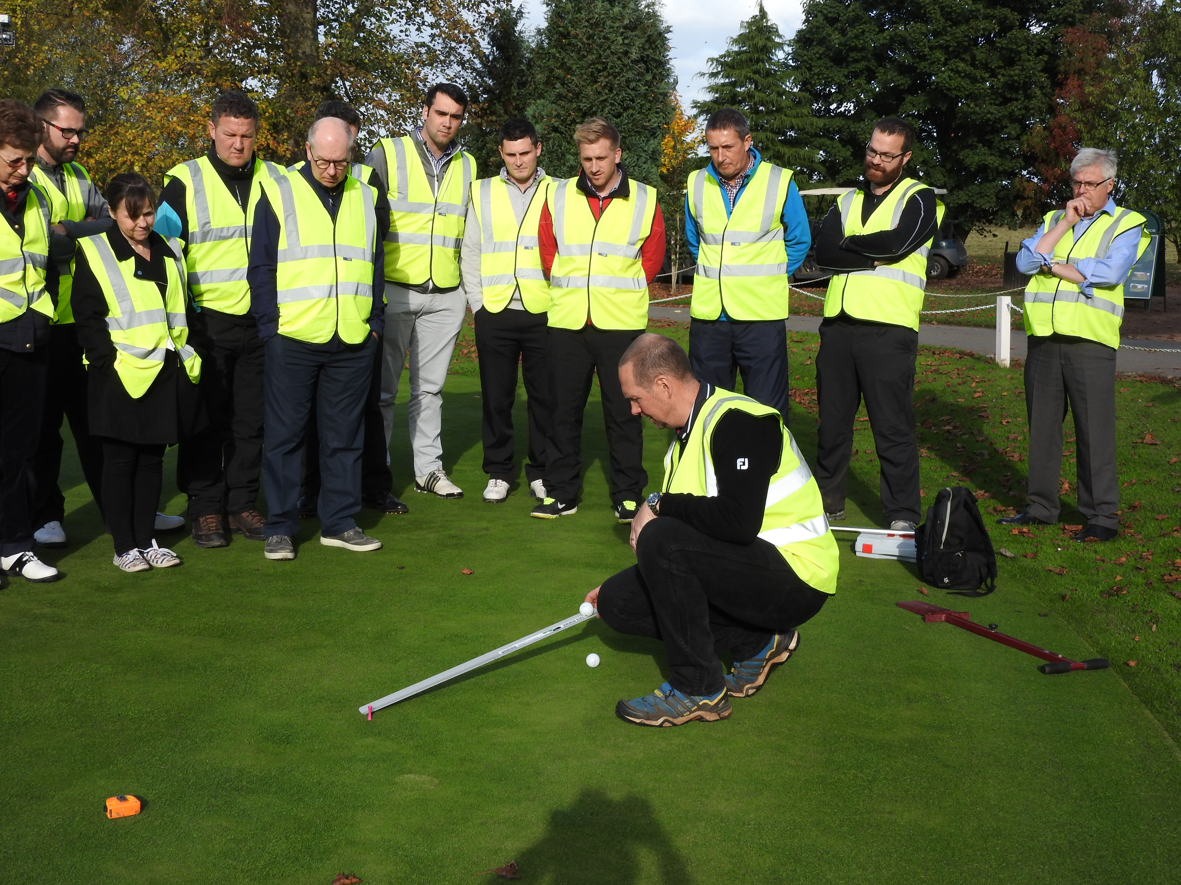

The CGCS, once again, wishes to remind clubs that they
must be aware of any changes to pension or employment
legislation.

Regional variations will shortly be published and
downloadable in PDF format from the BIGGA and GCMA
websites.

It should be further noted that the recommendations are linked to the four core areas of management the Secretary/Manager has overall responsibility for –

- Finance
- Golf Course
- Food & Beverage (including Bars)
- General Administration

In the future, these scales may be extended to reference the Continual Professional Development programme. (CPD).
“A brilliant five days – anyone considering, or already in golf club management, this course is not only advisable, it is a MUST” – RH Yorkshire

All other GCMA Regions

2018 The Committee for Golf Club Salaries
General Recommendations

The Committee for Golf Club Salaries

The Committee for Golf Club Salaries recommends that:

Club with Championship Status
and/or Substantial Additional Facilities £56,955

Club with 36 Holes £52,573

Club with 27 Holes £48.189

Club with 18 Holes and Responsibility of
All 4 “core” Management areas £43,809

Club with 18 Holes and Responsibility of
3 “core” Management areas £37,235

Club with 18 Holes and Responsibility of
- “core” Management areas £30,653
Club with 18 Holes and Responsibility of
only 1 “core” Management area £21,909

These figures are for the total package as outlined under General Recommendations.
- All Managers (Secretaries) be paid a salary based on the recommended scales. Recommended salaries are based on a total package that includes pension contribution by the club and any other benefits such as private health care, death in service benefit and all other benefits excluding accommodation.

- It is recommended that the club should make a minimum pension contribution of 7.5%.

- Any accommodation provided by a Club is NOT taken into account in the salary scales and is subject to negotiation between the parties.

- The Salary scales refer to the Manager (Secretary) of the Club and not to Assistant Secretaries.

- Scales are not specifically provided for 9 hole courses.Whilst it is recognised that these are half the number of holes and may
be similar pro rata in membership numbers to a standard (18 holes) club, the litigation issues such as Employment Law and Health & Safety are no less onerous on the Manager (Secretary). It is recommended that between 60% and 75% of the scales for a Standard course should therefore be applied.

- These scales are NOT inclusive of any out-of-pocket travelling expenses whilst conducting the Club’s business. Car mileage allowance should be paid in accordance with the scales of The Inland Revenue.

- These scales make no reference nor do they include any catering or drinks allowance the Club wishes to include.

- It is the recommendation of The Committee that the club should pay the annual subscription to GCMA National and Regional.This is not included in the package.

- It is the recommendation of the Committee that all Managers & Secretaries
receive additional support to attend the GCMA National Conference, all Regional Business meetings and educational Seminars at the Clubs expense.

GCMA London Area (Incorporating London & HC, Chilterns & HC Regions)

2018 The Committee for Golf Club Salaries

Club with Championship Status
and/or Substantial Additional Facilities £89,491

Club with 36 Holes £82,605

Club with 27 Holes £75,716

Club with 18 Holes and Responsibility of
All 4 “core” Management areas £68,841

Club with 18 Holes and Responsibility of
- “core” Management areas £58,516

Club with 18 Holes and Responsibility of
- “core” Management areas £48,189

Club with 18 Holes and Responsibility of
only 1 “core” Management area £34,428
GCMA South East Region & East Anglia Region

2018 The Committee for Golf Club Salaries

Club with Championship Status
and/or Substantial Additional Facilities £73,234

Club with 36 Holes £67,595

Club with 27 Holes £61,583

Club with 18 Holes and Responsibility of
All 4 “core” Management areas £56,327

Club with 18 Holes and Responsibility of
- “core” Management areas £47,876

Club with 18 Holes and Responsibility of
2 “core” Management areas £39,437

Club with 18 Holes and Responsibility of
only 1 “core” Management area £28,169

These figures are for the total package as outlined under General Recommendations. These figures are for the total package as outlined under General Recommendations.

