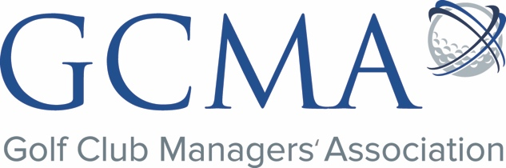

Communications Executive

The Golf Club Managers’ Association (GCMA) is seeking a Communications Executive - a newly created role that will be part of an exciting new phase for the Association as the delivery of its entire membership communications is overhauled.

Ideally interested in golf, the successful candidate will be key to the creation and commissioning of written and visual content, and the publication of that content to digital platforms. The role will support the Communications Manager in the delivery of the monthly GCMA members’ magazine, including assisting with account management for advertisers and sponsors, and assist with social media management. The role will contribute to the creation and delivery of communication strategies, and will also support the association’s day to day administration.

Supporting, and reporting to the Communications Manager.

The GCMA

The Golf Club Managers’ Association (GCMA) is the leading authority in golf club management, dedicated to delivering progressive, industry specific education programmes and networking opportunities, whilst offering high quality personal services and support for the development of our membership of over 1,800 golf club managers. Through a comprehensive programme of professional support the GCMA helps the development of golf clubs and ensures golf club managers and secretaries fulfil their potential.

Duties & Responsibilities: (Marketing and Communications)

- Creating original content and coordinating commissioned content for the association’s monthly magazine magazine and gcma.org.uk as required
- Publication of content to gcma.org.uk
- Publication of digital magazine
- Management of social media platforms
- Creating and sending member communications, such as enewsletters
- Writing press releases
- Contributing to development of marketing and communications plans and strategies
- Maintain content plans and database of contributors
- Supporting production of marketing materials
- Gathering and reporting of data and web analytics
- Conducting membership research

Duties & Responsibilities: (Sales and Commercial)

- Input into creation of appropriate commercial packages
- Maintaining and populating Recruitment and Business Directory areas of the website
- Maintaining after-sales care
- Conducting market research, for example using customer questionnaires and focus groups

Person Specification – qualifications, experience and behaviours

Key Skills and Attributes

- Ability to create quality written content, and to adapt to different audiences and platforms
- Skilled in creating, editing, and promoting written and visual content
- Web savvy and digitally literate – including proficiency with web publishing and digital design software
- Excellent organisational and planning skills, aptitude for detail and a high level of accuracy

Desired Skills and Attributes

- Interest in, and knowledge of, golf
- Prior experience in a similar role
- Commercial and customer focused
- Journalism / Marketing or other related qualifications
- Photography and video skills

Required Behaviours

- Excellent communication and interpersonal skills
- Self motivated and driven, with the ability to manage varying responsibilities
- Excellent command of the English language

Salary: £21,000
Hours: Usually 9am-5pm, permanent, full time
Holidays: 28 days including Bank Holidays
Working arrangements: Preferably office based – regular travel will be required (driving license and own car preferred) – flexible arrangements considered

You will be involved with ad hoc projects such as trade shows, industry and company events. Time off in lieu is offered for such events.

To Apply:

Please send your CV and a covering letter, detailing your relevant experience and suitability for the role, to Mike Hyde at: mike@gcma.org.uk
or
GCMA, Bristol and Clifton Golf Club, Beggar Bush Lane, Bristol, BS8 3TH.

The deadline for applications is 10am on Monday 5 December. Interviews will take place in Bristol on 13 and 14 December. If you wish to discuss the role in more detail, please contact Mike Hyde – mike@gcma.org.uk or 01275 391153.

